(Images are used as examples for where the attack is directed, not the rest of the pose. Please don’t wholly recreate these poses.)

**Randolf**

5A- Fast punch to the gut(Like where the fist is at, but with a less anime pose)

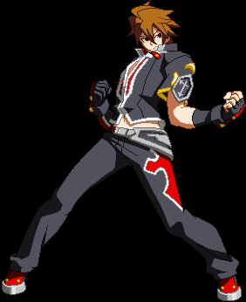

5B- Punch with other hand that reaches farther

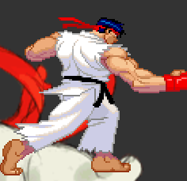

5C- Punch with initial hand that reaches the farthest.

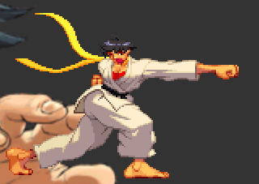

2A- Fast crouching jab(Keep in mind this model’s arm might be stretched a little)

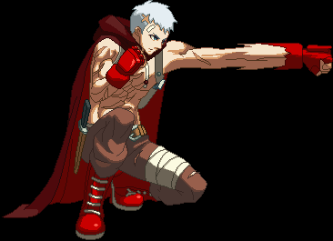

2B- Crouching uppercut(Maybe not as horizontally reaching)

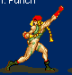

2C- Sweep that hits the opponent’s shins.

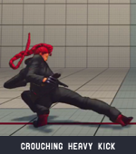

jA- A quick jab in the air(Not as much of a lean)

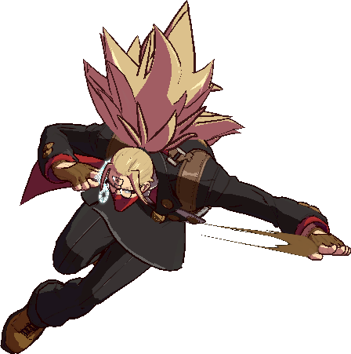

jB- Upwards kick(Perhaps not reaching as high)

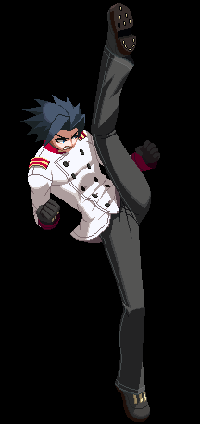

jC- Downward angled punch(About a 45 degree angle.)

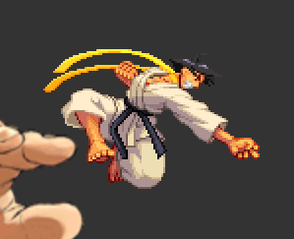

Normal Throw- Punches with 5B and 5C, launching the enemy away.

**Randolf Specials**

236- Fireball.

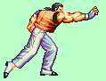

214- Tackle.

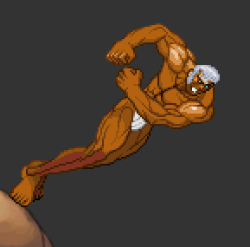

623- Invincible uppercut that varies in jump height by button press.

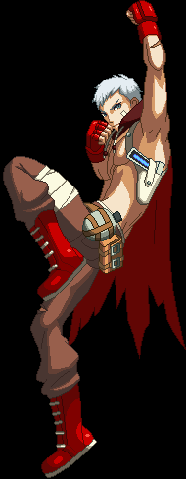

63214- Command grab. Grabs the opponent and suplexes them.

Super attack- Barrage of punches then launches with uppercut. Upon landing, Randolf throws a large fireball.

**Lynne**

5A- Fast knee attack.

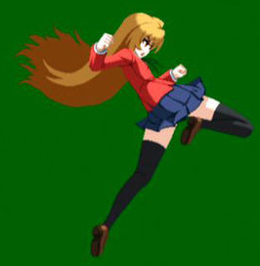

5B- Kicking attack, fully extends leg.

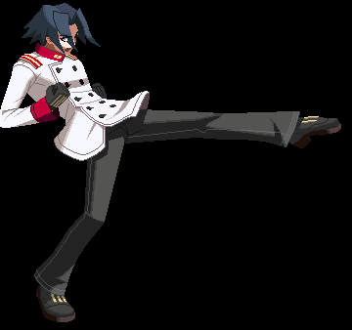

5C- Backwards roundhouse kick that moves Lynne forward(Standing position, kick may be angled higher.)

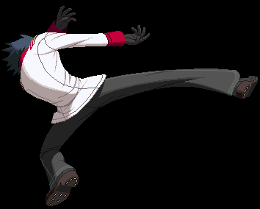

2A- Fast low kick.

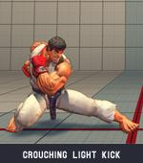

2B- Longer-ranged low kick

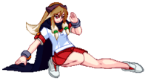

2C- Spinning sweep kick

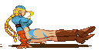

jA- Air knee attack

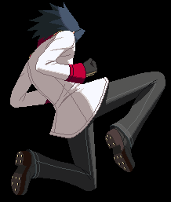

jB- Jumping kick at a low angle.

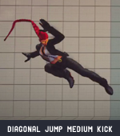

jC- Far reaching, horizontal kick

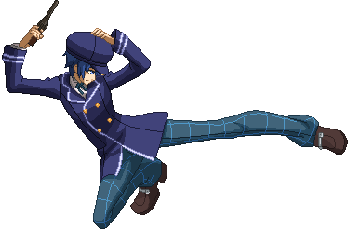

**Lynne Specials**

236- Fireball. (Find image of Juri’s fireball attack)

214- Slide kicks with follow ups depending on the button type(Sliding kick that’s low to the ground)

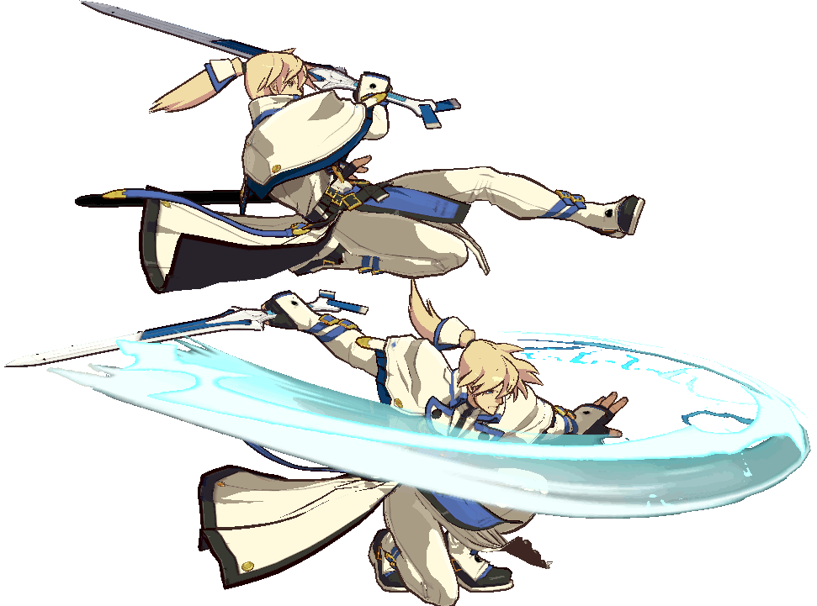

A/Light- Fast low follow up

Reuse crouching medium kick

B/Medium- Slower low follow up with combo potential

??

C/Heavy- Slow overhead follow up with combo potential.

Short jump with a swinging kick.

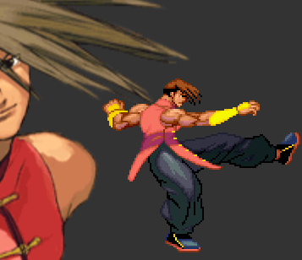

623- Similar to Cammy’s Cannon Spike. Jump height depends on button type.



Normal Throw- After grabbing, she knees the opponent, then kicks them away.

Super Attack- Flurry of kicks(with the pose of standing MK), then three of her “Cannon Spikes”(Light, medium, then heavy)